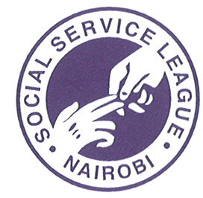
NOTICE OF
ANNUAL GENERAL MEETING

Notice is hereby given that the 81st Annual General Meeting (AGM) of the Members of the Social Service League, Nairobi will be held through electronic means (online/virtual meeting) at 4 P.M. on Friday, the 21st August 2020 at the Shah Meghji Rupshi Hall, M P Shah Hospital, Nairobi.

This AGM is convened and will be held in accordance with the provisions of the Companies Act 2015 Sec 280 and pursuant to Court Order issued by High Court of Kenya in Miscellaneous Civil Application No. E721 of 2020 in the matter of Kenya Private Sector Alliance Limited (KEPSA) and in compliance with the Registrar of Companies’ consent dated 9th June 2020 on the conduct of Virtual General Meeting.

Members will receive the meeting ID and login credentials through Email/mobile SMS and with the link through which those with an internet enabled device will be able to follow the proceedings in real time. For any assistance, member can send an email to: agm2020@mpshahhospital.org.

It is in the interest of members to continuously monitor the League’s website <www.mpshahhosp.org> due to the evolving Government directives as Covid-19 continues.

Phil Dastur
Hon. General Secretary
Social Service League
P O Box 14497, 00800
Nairobi
Tel: 020 4291000

